

MALIGNANT COMMENTS CLASSIFICATION

Submitted by:

CHITRAK Satyarthi

**ACKNOWLEDGMENT**

I would like to express my special thanks of gratitude to my mentor as well as the company for giving me the golden opportunity to do this wonderful project on the topic **MALIGNANT COMMENTS CLASSIFICATION**, which also helped me in doing a lot of Research and I came to know about so many new things I am really thankful to them.

**INTRODUCTION**

* Business Problem Framing

With the proliferation of smart devices and mobile and social network environments, the social side effects of these technologies, including cyberbullying through malicious comments and rumours, have become more serious. Malicious online comments have emerged as an unwelcome social issue worldwide.

* Conceptual Background of the Domain Problem

Recognizing the harm due to malicious comments, many concerned people have proposed anti-cyberbullying efforts to prevent it. In Europe, one such campaign was called The Big March, the world's first virtual global effort to establish a child's right to be safe from cyberbullying. The key motivation behind these campaigns is not just to stop the posting of malicious comments but also to motivate people to instead post benevolent comments online. Research in social networking has found benevolent comments online are not alone but coexist in cyberspace with many impulsive and illogical arguments, personal attacks, and slander. Such comments are not made in isolation but as part of attacks that amount to cyberbullying.

Both cyberbullying and malicious comments are increasingly viewed as a social problem due to their role in suicides and other real-world crimes. However, the online environment generally lacks a system of barriers to prevent privacy invasion, personal attacks, and cyberbullying, and the barriers that do exist are weak. Social violence as an online phenomenon is increasingly pervasive, a phenomenon manifesting itself through social divisiveness.

* Review of Literature

Research is needed to find ways to use otherwise socially divisive factors to promote social integration. However, most previous approaches to online comments have focused on analyzing them in terms of conceptual definition, current status, and cyberbullying that involves the writing of malicious comments. Still lacking is an understanding of why people post malicious comments in the first place or even why they likewise post benevolent comments that promote social integration. Unlike previous studies that focused on cyberbullying itself as a socially divisive phenomenon, this study, which we conducted in Korea in 2014, involved in-depth interviews with social media users in regard to both malicious and benevolent comments. To combat the impropriety represented by the culture of malicious comments and attacks, our study sought to highlight the problem of malicious comments based on the reasons people post comments. Here, we outline an approach toward shaping a healthier online environment with fewer malicious comments and more benevolent ones that promote social integration.

* Motivation for the Problem Undertaken

As an exploratory study, we took an interview approach. Unlike previous studies where the research typically reflected the perspective of elementary, middle, or high school students, we included in-depth interviews with a broader range of age groups. Questions dealt with reasons for benevolent and malicious comments, problems associated with online comments, and suggestions for addressing the problems.

As a qualitative study, we adopted the convenience-sampling approach for selecting interviewees. For qualitative researchers, it is the relevance of interview subjects to the research topic rather than their representativeness that determines how they select participants. The interviewees should be able to explain the reasons or motivations for such postings. We thus checked whether interview subjects had posted comments online.

**Analytical Problem Framing**

* Data Sources and their formats

Usually the data was analysed on the basic knowledge, which were required, basically the data with the null values were removed. Rest of the data was analysed using histogram and other charts which were required for the EDA and were considered or removed biased on the analysis.

* Hardware and Software Requirements and Tools Used

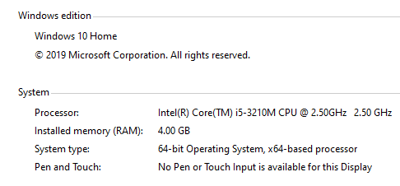

**Model/s Development and Evaluation**

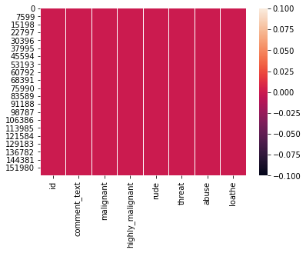

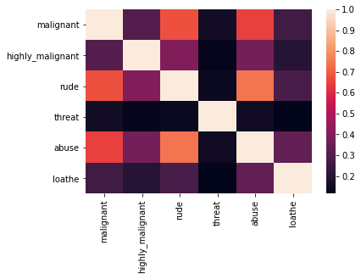

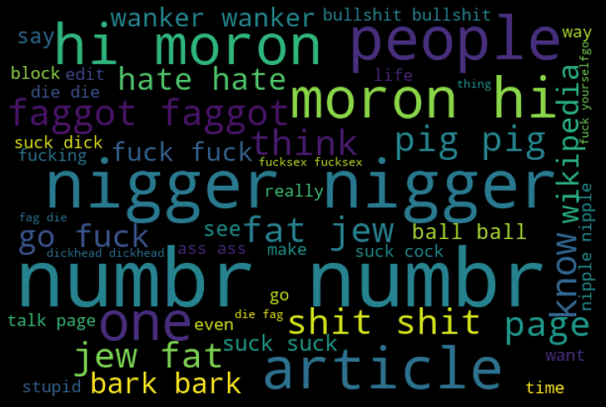

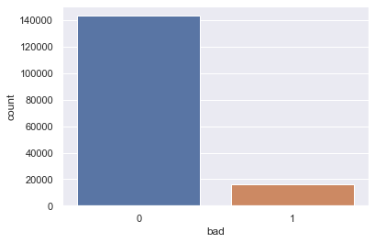

**CONCLUSION**

* Key Findings and Conclusions of the Study

malignant 2.745854

highly_malignant 9.851722

rude 3.992817

threat 18.189001

abuse 4.160540

loathe 10.515923

dtype: float64

* Learning Outcomes of the Study in respect of Data Science

Random forest and logistic regression were the best algorithms to use for this kind of problem as their accuracy was highest with 0.96.

The study shows how to take care of the malignant comments as they results in destruction and this is one of the serious issue which people ignore.

* Limitations of this work and Scope for Future Work

There will always the scope of improvement in any study. As far as the current study is concerned it gives all the insights with the solution of the problem statement given according to my knowledge.